

**Data Analysis project named “Explore Weather Trends”:**

***OVERVIEW:*** We will be analyzing local and global temperature data and compare the temperature trends followed at local and global level.

***REQUIREMENTS:***

* Extract the required data
* Outline the local and global trends
* Make observations based on trends

***PROCEDURE:***

***STEP 1:*** First of all for analysis the key requirement is **DATA** which we will derive using the SQL queries, mentioned below

For obtaining Global data:

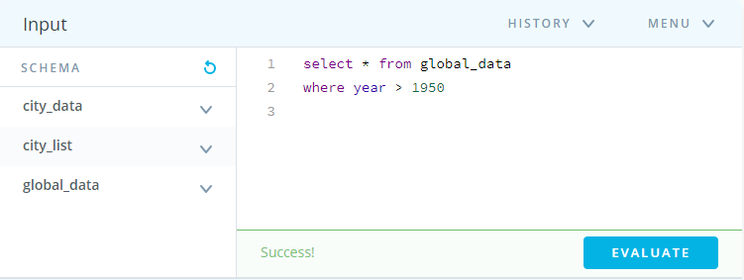

For obtaining Local data: which we have selected as “Delhi”

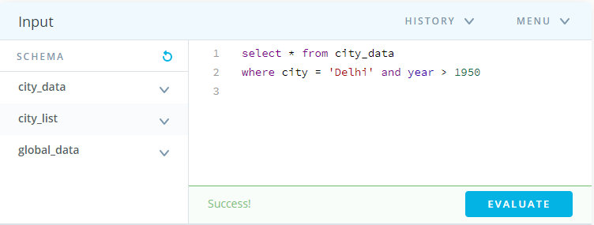

***STEP 2:*** After we figure out the SQL query, we will transfer the data available in a CSV file format using the option provided option provided by Udacity on their platform

Data will be available in format below

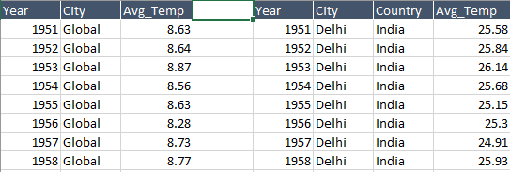

***STEP 3:*** So as to make a smooth comparison trends between local and global temperature trends, we will calculate Central Moving Average (CMA) for which the formula is mentioned below

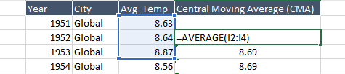

After calculating for both data preview will be

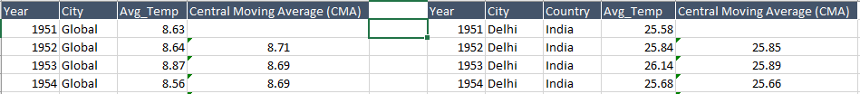

***STEP 4:*** At last, we will visualize the data independently for local and global temperatures and then together in a single chart to get the observations with both the faces in view.

Data is visualized using Line Charts option in excel (yellow highlighted).

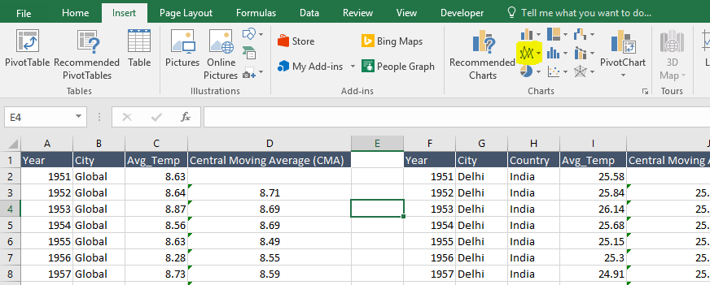

Global Temperature trend (individual)

Local Temperature trend (individual)

Comparison between Global and Local Temperatures

***OBSERVATIONAL ANALYSIS:***

* The maximum moving average Global temperature marked during period (1952-2012) was 9.6°C in 2006 and max for Local temperature marked was 26.25°C in 2009
* The difference in temperatures between Global and Local levels indicate Local city “Delhi” is very hot for an individual to reside in
* After the year 1975, Global temperature has shown a regular upward trend (which clearly depicts the signs of increasing Global Warming)
* There are huge ups and downs in Average Local temperature; after 1975 Local temperature is showing a new maximum after an approximate interval of one or two decades followed by large dips too in it
* On comparison we can see that there is a approximately constant difference between two over the whole time period (1952-2012)

***REFERENCE:***

For Udacity Logo present at the top

* https://images.app.goo.gl/NDzZUAudDZ9fscXQ8